Photoelectron Response to Solar Flares

A proposal to the Naval Research Laboratory in response to Broad Agency Announcement (BAA) N00173-19-S-BA01

Srimoyee Samaddar

September 30, 2019

The goal of this proposal is to quantify photoionization and production of primary and secondary photoelectrons in the D and E region ionosphere in response to changes in solar flux. We propose to determine the altitudes of photoionization and photoelectron production due to high energy photons in the x-ray wavelength ranges, especially during the solar flares. The solar flares consist of photons with high energy, high fluxes and are also highly variable in the x-ray ranges, so they must affect the photoionization and photoelectron flux production in altitudes below 90 km. Most of the existing models do not consider spectral variability in the x-ray ranges, therefore, we need better photoelectron models to study their effects in the earth’s ionosphere at lower altitudes. This proposal addresses that need.

The solar flux, shortward of 30.4 nm deposits energy into the Earth’s thermosphere and initiates chemical processes that affect the composition and structure of the ionospheric D and E regions. One of the primary processes is the photoionization of the major neutral constituents N2, O2 and O. The photoionization of the major species leads to the formation of energetic photoelectrons. These primary photoelectrons create secondary electrons that can cause further ionization, dissociation, and excitation of particles. This process affects the dynamics of the Earth’s ionosphere and so it is important to know what wavelengths cause ionization at what altitudes, with a high level of accuracy.

In order to study the photoionization and photoelectron production, we will develop an improved photoelectron model that can resolve the altitude profiles of these fluxes with a high degree of accuracy compared to previous models. The new model is an improved version of the GLOW model [Solomon et al., 1988; Solomon and Abreu 1989; Bailey et al 2002] and is based on the two-stream method of phototelectron flux calculation introduced by Nagy and Banks (1970). Our photoelectron model will be able to resolve solar energies below 3nm with high spectral resolution. This will help us to analyze solar fluxes in very fine wavelength bins and with very high energies, up to hard x-rays energies. We will also improve the tabulation ionization and absorption cross-sections of the neutral species and their various ionization and dissociation states at all wavelengths with the newest available laboratory data.

A secondary goal is to resolve the issue of the photoionization of the Lyman beta emission at 102.5 nm. We know that Lyman beta causes photoionization of O2, however, since the ionization threshold of molecular oxygen is very near that wavelength, most models improperly resolve the ionization and absorption cross-sections around it, which results in incorrect altitude profile for photoionization due to Lyman beta emission. With our improved cross-sections, we hope to resolve this issue of the photoionization of molecular oxygen by Lyman beta.

Initial Results

Figure 1 shows the initial results of photoionization and photoelectron fluxes for a synthetic input solar spectrum. The left panel is the spectrum used to generate the photionization and photoelectron rates. The solar flux has non-zero values up to 500 angstroms and was supplied by NRL as a test spectrum.The flux after the 500 Angstrom is obtained from a modified EUVAC model obtained from Solomon and Qian (2005) and Woods and 124 Rottman (2002) and extends to 1075 angstrom. Thus we have the Lyman beta line at 1026 Angstrom and can study its effects on the photoionization rates. The spectrum is plotted on a logarithmic scale. The solar spectrum in the x-ray range has been modified to have high wavelength resolution and extends to energies of 27keV. The photoionization rates and photoelectron ionization rates fluxes for the three neutral species, N2, O2 and O are shown in the right panel. The photoionization rates are shown in bold lines and the photoelectron production rates are shown in dashed lines. The model resolves these rates from an altitude of 40 to 300 km. Our initial results show that although the solar flux is very small in the x-ray ranges compared to the longer wavelength bins, the model is able to resolve its effect at altitudes lower than 90 km, i.e., we are able to see photoionization and photoelectron production at these low altitudes. Therefore, the model should be able to correctly determine the photoionization 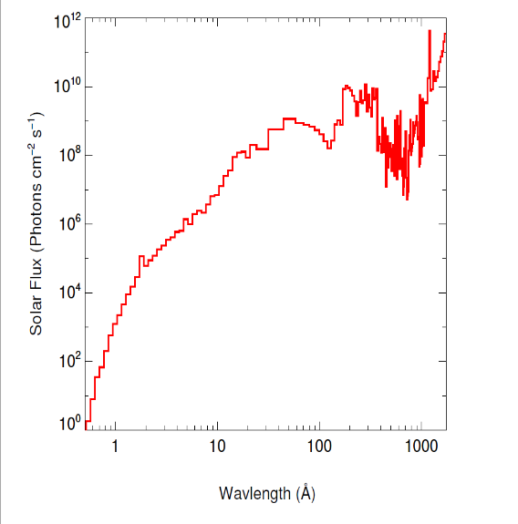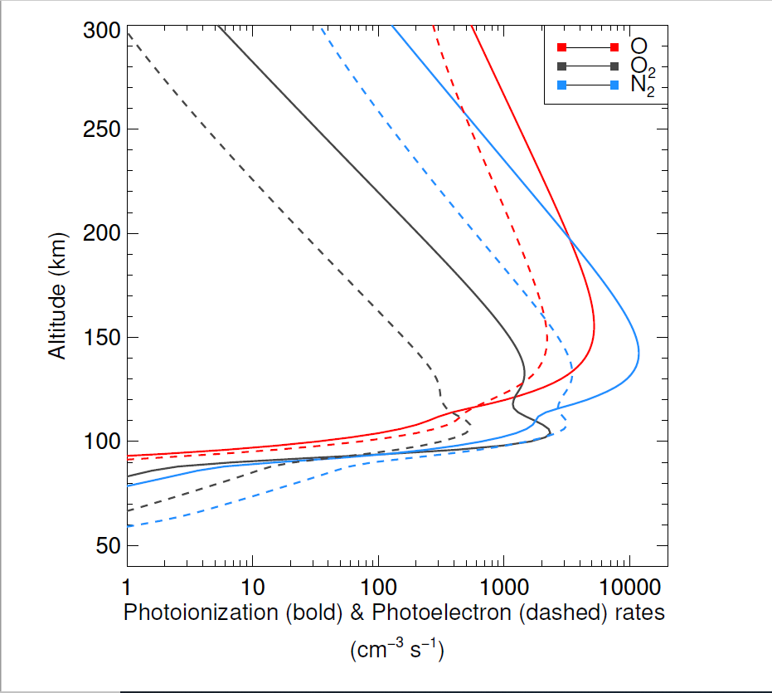and photoelectron rates fo r high resolution x-ray fluxes, including solar flares.

Figure 1: left: Input Solar Flux; right: Photoionization and photoelectron rates for neutral species O, O2, N2

Project Implementation and Funding

The photoelectron model is being developed by Virginia Tech’s Center for Space Science and Engineering Research. We plan to test the model with synthetic solar spectra developed by the Space Science Division, Naval Research Laboratory (NRL). We have promising initial results as shown above. We propose a one-year project, beginning November 1st, 2019 and ending in October 31, 2020. We have estimated a fund amount of eight thousand US dollars which will be used for travel related to project collaboration. This includes travel to NRL in Washington DC for collaboration on solar spectra and our results, as well as travel funds to present our results at science team meetings and conferences.